Volunteer Handbook

Welcome

Welcome to the Bing Crosby Theater volunteer team! The Bing Crosby Theater is a historic performing arts and specialty film theater. We are here to benefit the community and the arts of Spokane.

Volunteer efforts play an integral part in maintaining the theater and contributing to its success. Your involvement and dedication is genuinely appreciated!

This handbook is intended to give you information about your position, to provide a summary of our policies and procedures, and to serve as a general reference of volunteer expectations. If you need any information not contained in this guide, please contact your volunteer coordinator, Marianne Salina, at 509-534-5805 or marianne@gvdcommercial.com

Benefits of Being a Volunteer

- Build your resume
- Give back to the community
- View world class performances
- Meet new friends
- Networking opportunities

VOLUNTEER POSTIONS:

- Poster Volunteers

Poster distribution volunteers are essential to our Friends of the Bing team because they help ensure the success of the show before the show debuts. Volunteers within this position must have reliable transportation and flexibility to make a considerable number of stops within a particular poster route. Our Poster Volunteers are also important ambassadors of the Bing Theater and the work of Friends of the Bing. It is important to maintain a respectful and professional demeanor in every interaction while you represent the theater.
Eligibility

The safety and comfort or our volunteers and our patrons are important to us, and because of this we require poster volunteers to maintain these basic qualifications:
- Active WA state driver’s license
- Familiarity with Spokane’s downtown streets and outlying neighborhoods
- Ability to stand and or walk for stretches of time
- Willingness to commit to at least 3 months at 8 hours per month in 2 hour stretches
- Positive attitude and willingness to make adjustments to course or plan when needed
- Professional and personable attitude

Essential Duties for Poster Volunteers:

- Check in with Volunteer Coordinator (Marianne Salina) before beginning any route at Friends of the Bing headquarters (909 W. 1st Ave). Make sure you are clear which posters are going out that day, and that you have all the materials you need before starting.
- Familiarize yourself with the route for which you are responsible. If you do not know where something is located, ask questions or consult Google Maps.
- Bring Route List with you as you drop off posters. Initial after each stop where you dropped posters off.
- Make note of changes in address or of establishments that DO NOT wish to carry our posters so we can keep our files updated.
- Remain respectful and friendly as you engage with businesses. If they decline a poster for some reason, don’t challenge them. It is their business and they are doing Friends of the Bing a favor by showcasing our events.
- Please dress in comfortable, professional clothing during poster distribution.
- Explain that you are a volunteer for Friends of the Bing to each establishment.
- Bring back any remaining posters and the route list to Marianne. Poster volunteers earn 2 tickets to each event for which they successfully deliver materials.
- Any questions or concerns about this role may be directed to Marianne Salina, 509-534-5805 or Marianne@gvdcommercial.com

- Bing Crosby Theater Volunteers

Theater Volunteers are an important part of our events, and are ambassadors for the Bing Crosby Theater. Each volunteer is responsible for personally upholding the reputation of our theater, and for making sure that all of our patrons are given an experience that will keep them returning. To ensure that our patrons have a positive experience every time, we ask that all volunteers remember and honor the policies and general practices of the Bing Crosby Theater.

Responsibilities

Promptness
We request that you arrive no later than the time specified by the volunteer coordinator, typically one hour and fifteen minutes prior to the start of any show. It is critical that you arrive on time and be ready to go.

Arrival
Upon arrival, each volunteer is required to sign in on the volunteer sign in sheet, located in the back room. Volunteer briefing will take place 10 minutes after arrival, in the lobby of the theater. Onsite at events, volunteers will report to the General Manager, Jeff Peterson, or the Manager On Duty. Please arrive 1 hour before the start of the show. Volunteer entrance is the “Stage Door” located on Sprague Ave just down from the main entrance.

Departure
Please sign out on the same formed you signed in on, and inform the manager on site of your departure.

Attire
Our patrons must be able to easily identify who is able to assist them. Thus, we require our volunteers to adhere to the following dress code:

- Clean shirt or blouse (no logos)
- Tasteful closed toed shoes (no flip-flops)
- Dressy/casual—ties are not necessary, but consider your appearance as an identifying feature for patrons to know you are there to assist them.

For ushers: Please bring and carry a small flashlight for every performance. If you do not have one, we have a limited supply of loaners.

During Performance

- Please wait until 20 minutes after performance/event starts, before leaving your post, unless otherwise specified.
- Volunteers are welcome to watch the performance/film after they have performed the agreed upon duties, and must sit in seats that are empty.
- If volunteering through to the end of the event, it is preferable that the volunteer sits in an aisle seat, or somewhere they are accessible to the on duty manager. Please notify your on-duty manager of where you are going to be seated, so you are available if needed.
- For all volunteers, even if you have signed out before sitting in on the event, we ask that you keep an eye out for and report the following to an on-site manager:
- If you notice an altercation between patrons
- If you notice the use of outside alcohol brought into the theater or consumed in the auditorium
- If you notice equipment not working as it is supposed to
- If you notice anyone besides personnel using equipment when they are not allowed to, or in an area designated only for sound and tech personnel
- If you notice unsafe or inappropriate conduct, including but not limited to dangling over the balcony, throwing things over the balcony, unsuitable yelling during a performance, obvious drunkenness/belligerence, using restrooms designated for the opposite sex, and patrons letting friends enter through the side handicap entrance.

- Theater Ushers

Theater usher volunteers are essential to our guests having a pleasant and stress free experience. Volunteers within this position must be friendly, outgoing and willing to go above and beyond. It is important to maintain a respectful and professional demeanor in every interaction while you represent the theater.

Eligibility

The safety and comfort or our volunteers and our patrons are important to us, and because of this we require volunteers to maintain these basic qualifications:

- Ability to climb stairs
- Ability to stand/be on your feet for 1-3 hours
- Tolerance to heights, as you may be seating patrons in the balcony areas
- Professional and personable attitude
- Willingness to keep commitments

Usher Guidelines

- Before volunteering at your first event, familiarize themselves with the facility, theater seating chart, theater website, and the theater policies.
- If you are unable to make it to an event, please inform the volunteer coordinator or house manager at least 24 hours prior to event (if possible), so that we can find a substitute for you. (See contact info above)
- Absolutely no consumption of alcohol is tolerated while volunteering.
- Personal belongings can be stored in the back room or behind the concessions counter for safekeeping. However, the theater is not responsible for lost or stolen items, so please leave valuables at home.
- Flashlights, nametags, and any other supplies used must be returned to their appropriate places before leaving.
- The manager on duty is ultimately responsible for all people in the house. If an issue arises or you need help with anything, ask the manager or assistant manager on duty.
- If you need to leave earlier than what you committed to, please give notice in advance.
- Volunteers working in concessions, are required to provide a copy of their food handler’s card and MAST certification, prior to first shift of volunteering

Basic Usher Duties:

- Please treat customers, house staff, performers, and fellow volunteers with respect.
- Provide general assistance and guidance to patrons as needed
- Ensure event programs, fliers, and coupons are handed out at the appropriate times before and after the event.
- Assist patrons in locating where concessions and other amenities are located such Ovations Bar at the top of the Bing Theater and Sapphire Lounge.
- Other duties as assigned by the Manager on Duty.

- Ticket Booth Volunteers

Ticket Booth volunteers are the first point of contact the day of the event. Volunteers within this position must be friendly, outgoing and perform well under pressure. It is important to maintain a respectful and professional demeanor in every interaction while you represent the theater.

Eligibility

These volunteers must attend a training session on the ticketing system before their first shift. Volunteers must have money handling experience and be able to count back change.

a) Box Office Volunteer

- Sell tickets in ticket booth one hour before each event
- Become knowledgeable of company procedures regarding the use of sales terminals
- Accurately control money in the assigned cash drawer including a drawer count after shift.
- Two inaccurate balances will result in your no longer being able to handle money on our behalf.
- Accurately count out your till after shift and sign form

b) Ticket Scanner Volunteer

- Ticket Scanner volunteers support the staff at the ticket booth as patrons are arriving.
- If guests have printed tickets, scan the ticket before allowing entry
- If guests have gone paperless, the ticket scanner will locate the patron name in scanning device, and then scan them through.

General Information

Emergency Exits
Emergency exit signs are marked by illuminated neon “EXIT” signs. Please familiarize yourself with all exit locations. In the event of emergency, you must direct all patrons to the closest accessible exits.

Accidents/Issues
In case of an accident suffered by a patron, volunteer or staff member, or any problem you feel you cannot resolve on your own, please notify the on site manager immediately. Never argue with a patron; always be polite and refer the dispute to the proper person.

ADA Accessibility Seating
Seating for mobility-impaired patrons is located on the main level, on the far left and far right doors entering the auditorium. Patrons need to have purchased a ticket with the ADA accessible seating request, in order to sit in the designated area.

Refreshments
Refreshments are available for purchase at the concessions stand, and we do not allow outside food or drink into the theater. Patrons are welcomed to take food and drink they purchased at our concessions counter, into the theater, unless otherwise directed by one of our presenters.

Smoking
Smoking is not allowed anywhere inside the theater. Patrons are welcomed to smoke outside, with their retained ticket stub.

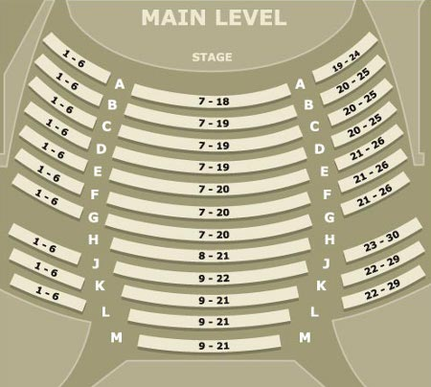
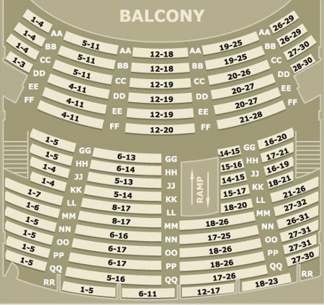

Acknowledgement

I, __________________________________________________________, acknowledge that I have read the volunteer handbook in its entirety. By signing below, I acknowledge that I understand the job description and what is expected of me as a volunteer.

Name (printed)

Signature Date

* Please sign and return this page to your volunteer coordinator.

